Slope and Unit Rate Review

Slope can de defined as: ______________________________________________________________________

To calculate slope you need __________________________________ and the __________________________

Slope =

Finding slope from graph:

 

Find the slope of the lines from these tables.

 

We can even find slope without calculating. When an equation is in _____________________________________. The slope and y-intercept can be pulled out of the equation.

Find the slope and y-intercept from the following equations.

  

Unit rate/ Rate of change can be defined as: _______________________________________________________.

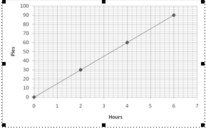You can find unit rate from graphs:

The graph below shows the number of pies produced at a bakery as a function of time.

How many pies can the bakery make per hour?

**Reminder** - set up the problem like you would like to say it

For example: __________ per __________ =

Or from real world situations in a word problem:

1. If you can buy one can of pineapple chunks for $2 then how many can you buy with $10?

**How do you want to say it?**

1. It takes 120 minutes to travel 360 miles on a plane. At this rate, how many miles does the plane travel in 6 hours? (**Be careful of the time conversion!)**

**How do you want to say it?**

1. It takes 2 hours to travel a distance of 180 miles by train. At this rate, how many miles does a train travel in 3 hours?

**How do you want to say it?**

1. It takes 5 hours to travel 360 miles by car. At this rate how many miles can a car travel in 9 hours?

**How do you want to say it?**

Find the slope of the following graphs.

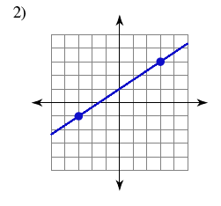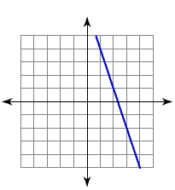 

Use the unit rate in the graph above to predict how much it will rain in 35 days.

