Objective: I can evaluate algebraic expressions involving rational values for coefficients and/or variables.
1. 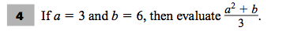
First try: | Second Try:
Objective: I can evaluate algebraic expressions involving rational values for coefficients and/or variables.
2. 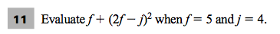
First try: | Second Try:
Objective: I can translate between verbal and symbolic representations of real-world phenomena involving linear equations.
3. 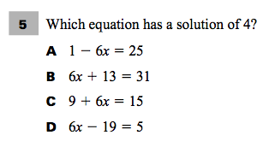
First try: | Second Try:
Objective: I can translate between verbal and symbolic representations of real-world phenomena involving linear equations.
4.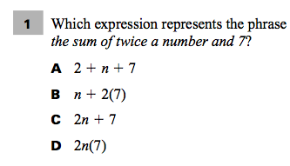
First try: | Second Try:
Objective: I can translate between verbal and symbolic representations of real-world phenomena involving linear equations.
5.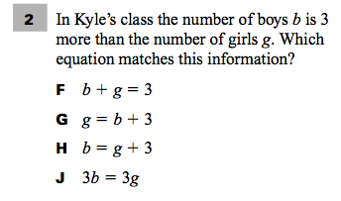
First try: | Second Try:
Objective: I can translate between verbal and symbolic representations of real-world phenomena involving linear equations.
6.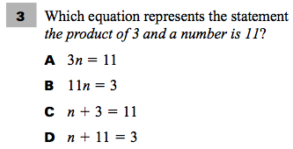
First Try: | Second Try:

